**Fall 2019 COMP 7706 Software Architecture**

**Final Project Design Document**

1. Write a common use case for each user story.
   1. As a user, I want to change my password and/or full name.

|  |  |
| --- | --- |
| Actor actions | System Response |
| 1. Click the “Manage Account” button on the main menu. | 2. A window will appear displaying the “Manage Account” form. |
| 3. Complete the “Manage Account” form with the desired updates. Then click the “Save” button. | 4. The information provided by the user will be used to update the current user in the database. Display a popup informing the user that the action was successful. |
| 5. Click “Ok” on the confirmation window. |  |

* 1. As an admin, I want to add a new user into the system.

|  |  |
| --- | --- |
| Actor actions | System Response |
| 1. Click the “Add New User” button on the main menu. | 2. A window will appear displaying the “Add New User” form. |
| 3. Complete the “Add New User” form with the desired user information. Then click the “Save” button. | 4. The information provided by the user will be used to create a new user entry in the database. Display a popup informing the user that the action was successful. |
| 5. Click “Ok” on the confirmation window. |  |

|  |  |
| --- | --- |
| Actor actions | System Response |
| 1. Click the “Manage Product” button on the main menu. | 2. A window will appear displaying the “Manage User” form. |
| 3. Complete the “Manage User” form with the desired user information. Then click the “Save” button. | 4. The information provided by the user will be used to update the existing user entry in the database. Display a popup informing the user that the action was successful. |
| 5. Click “Ok” on the confirmation window. |  |

* 1. As an admin, I want to update the type/class of a user into the system (e.g., from cashier to manager).

|  |  |
| --- | --- |
| Actor actions | System Response |
| 1. Click the “Manage Product” button on the main menu. | 2. A window will appear displaying the “Manage Products” form. |
| 3. Complete the “Manage Products” form with the desired product information. Then click the “Save” button. | 4. The information provided by the user will be used to create a new product entry in the database. Display a popup informing the user that the action was successful. |
| 5. Click “Ok” on the confirmation window. |  |

* 1. As a manager, I want to add a new product or update a current product in the system.

|  |  |
| --- | --- |
| Actor actions | System Response |
| 1. Click the “View Summary Report” button on the main menu. | 2. A window will appear displaying the “Summary Report”. |

* 1. As a manager, I want to view a summary report of sales from the system.

|  |  |
| --- | --- |
| Actor actions | System Response |
| 1. Click the “Add/Update Customer” button on the main menu. | 2. A window will appear displaying the “Manage Customer Information” form. |
| 3. Complete the “Manage Customer Information” form with the desired customer information. Then click the “Save” button. | 4. The information provided by the user will be used to create a new customer entry in the database. Display a popup informing the user that the action was successful. |
| 5. Click “Ok” on the confirmation window. |  |

* 1. As a cashier, I want to add a new customer or update a current customer in the system.
  2. As a cashier, I want to add a new purchase or update a current purchase (only price and quantity) in the system.

|  |  |
| --- | --- |
| Actor actions | System Response |
| 1. Click the “Add Purchase” button on the main menu. | 2. A window will appear displaying the “Add Purchase” form. |
| 3. Complete the “Add Purchase” form with the desired product information. Then click the “Save” button. | 4. The information provided by the user will be used to create a new purchase entry in the database. Display a popup informing the user that the action was successful. |
| 5. Click “Ok” on the confirmation window. |  |

|  |  |
| --- | --- |
| Actor actions | System Response |
| 1. Click the “Add Purchase” button on the main menu. | 2. A window will appear displaying the “Add Purchase” form. |
| 3. Complete the “Add Purchase” form with the desired product information. Then click the “Save” button. | 4. The information provided by the user will be used to create a new purchase entry in the database. Display a popup informing the user that the action was successful. |
| 5. Click “Ok” on the confirmation window. |  |

* 1. As a customer, I want to add a new purchase into the system.

|  |  |
| --- | --- |
| Actor actions | System Response |
| 1. Click the “View Purchase History” button on the main menu. | 2. A window will appear displaying the “Purchase History” results for the current user. |

* 1. As a customer, I want to view my purchase history into the system.
  2. As a customer, I want to search for product information (based on name, price) in the system.

|  |  |
| --- | --- |
| Actor actions | System Response |
| 1. Click the “Search Product” button on the main menu. | 2. A window will appear displaying the “Search Products” results. |

1. Sketch the screens the system should display in each use case.
   1. Manage Account  
      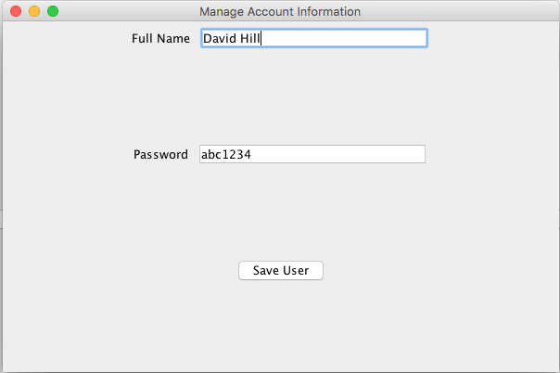
   2. Customer View UI  
      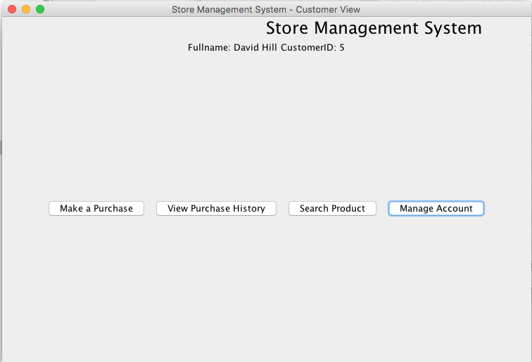
   3. Make a Purchase  
      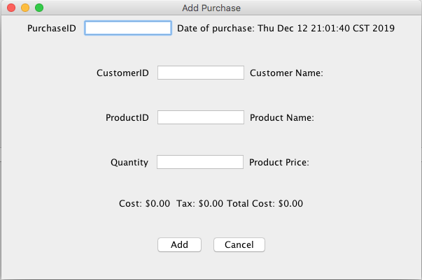
   4. View Purchase History  
      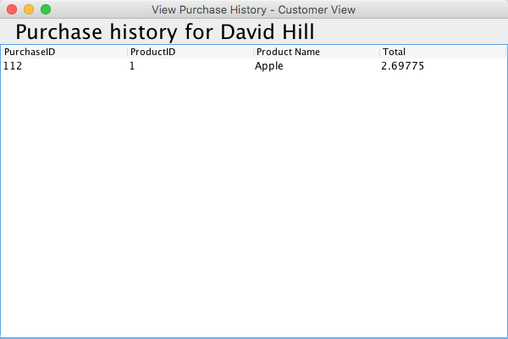
   5. Search Product  
      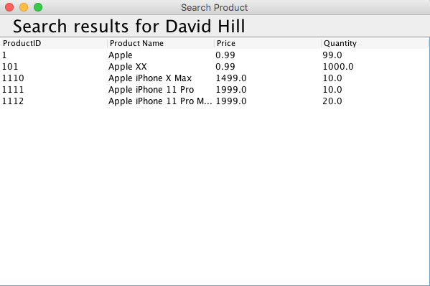
   6. Cashier View UI  
      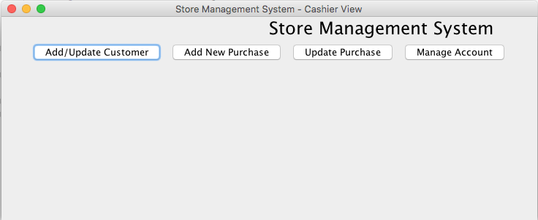
   7. Add/Update Customer  
      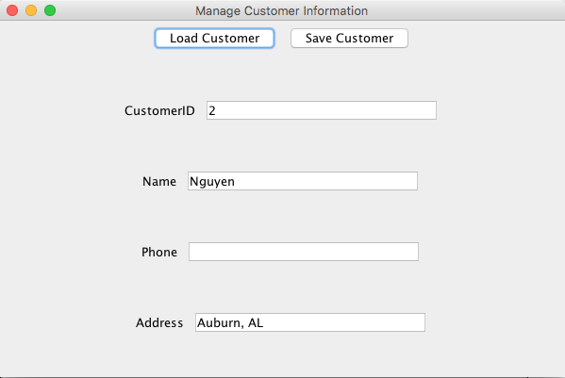
   8. Add New Purchase  
      
   9. Update Purchase  
      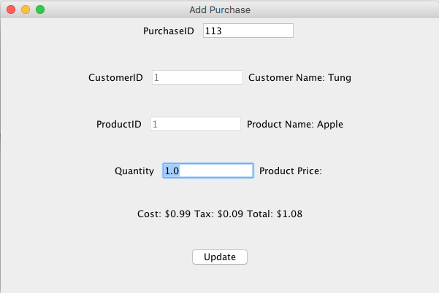
   10. Manager View UI  
       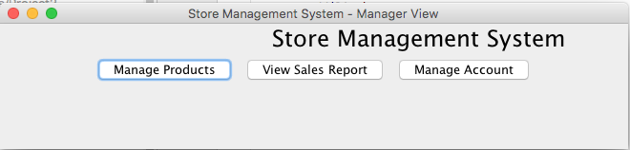
   11. Manage Products  
       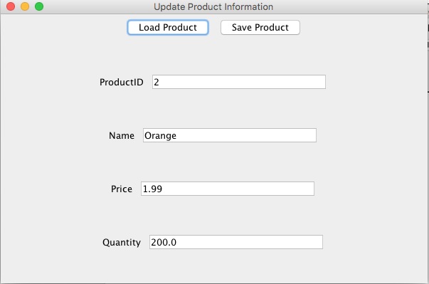
   12. View Sales Report  
       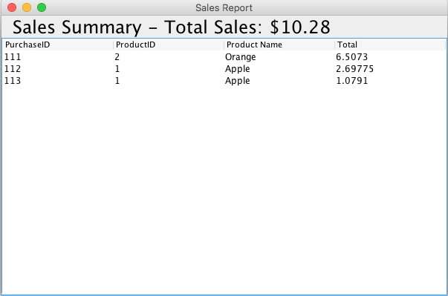
   13. Admin View UI  
       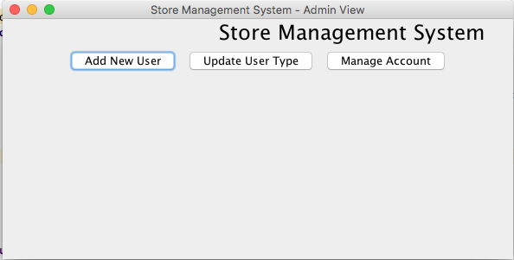
   14. Add New User  
       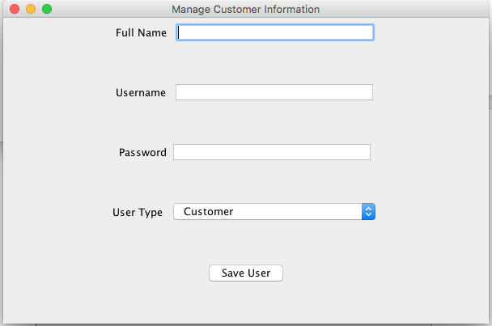
   15. Update User Type  
       